## Identify the concepts

|  |  |  |
| --- | --- | --- |
| Responsibility Description | Type | Concept Name |
| Checks if the user has not logout yet. | K | LogStateChecker |
| Provides the place for uploading pictures or calling camera. | D | UIRender |
| Check if the button “upload” is pressed | K | ButtonChecker |
| Call Camera/Photos | D | SystemCall |
| Upload pictures | D | Server |

## Design Sequence Diagram

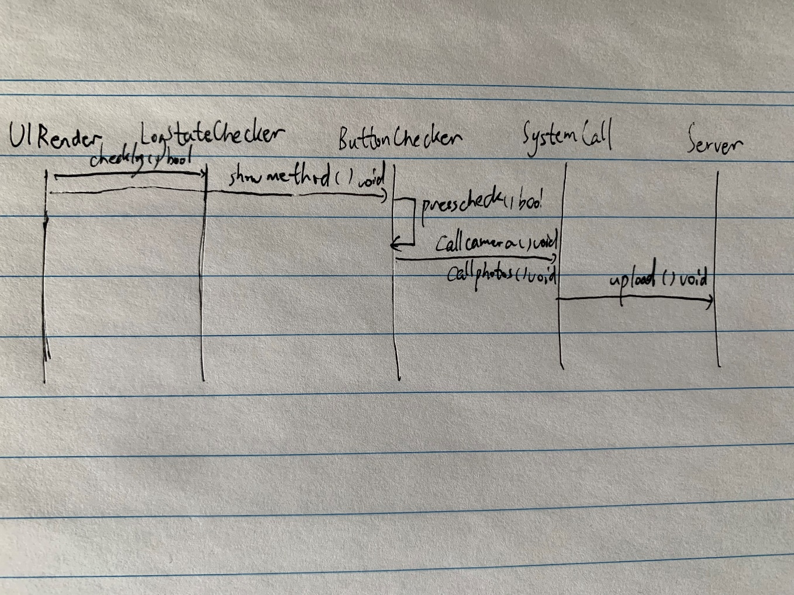

UIRender:showmethod():void

LogstateChecker: checklog():bool

ButtonChecker:presscheck():bool

SystemCall:callcamera():void callphotos():void

Server:upload():void

## Documentation

LogStateChecker检测是否处于登录状态。UIRender提供交互界面，选择调用相机或相册的界面。Systemcall调用相机或相册。Server负责上传照片到云端。